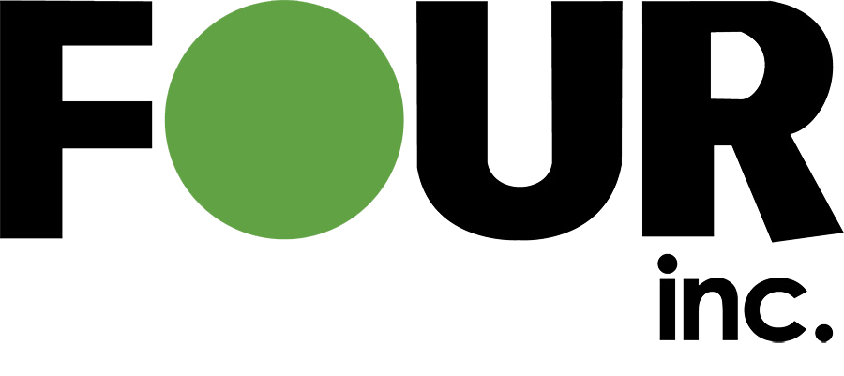

Response to RFQ# for Agency
Four Inc. Proposal # XXXXXXXXX

Date

Submitted To:
Customer Name
Agency
Address
Email
Phone #

Submitted By:
Insert Your Name
2303 Dulles Station Blvd., Suite 105
Herndon, VA 20171
Phone: 703-965-9175
email@fourinc.com

Use or Disclosure Restrictions This proposal or quotation includes data that shall not be disclosed outside the Government and shall not be duplicated, used, or disclosed – in whole or in part – for any purpose other than to evaluate this proposal. If, however, a contract is awarded to this offeror or quoter as a result of – or in connection with – the submission of this data, the Government shall have the right to duplicate, use, or disclose the data to the extent provided in the resulting contract. This restriction does not limit the Government’s right to use information contained in this data if it is obtained from another source without restriction. The data subject to this restriction are contained in sheets marked accordingly.

CAGE: 4M4Z2 | TIN: 75-3227157 | DUNS: 789007064 | UEI: X1JJYEW4HAN9
Logo Here

Table of Contents
1. Overview 4
a. Four Inc. Overview 4
b. OEM/Partner Overview 4
2. Technical Approach/Proposed Solution 4
3. Product List 4
4. Price Proposal 5
5. Past Performance 5
a. Past Performance #1 5
b. Past Performance #2 5
c. Past Performance #3 5
d. Past Performance #4 6
e. Past Performance #5 6
6. Terms & Conditions 6
7. Attachments 6

Overview
Four LLC (d.b.a. Four Inc.) is pleased to submit this proposal in response to solicitation number XXXXXXXX

Four Inc. Overview
Headquartered in Herndon, VA, Four Inc. is a public sector provider of information technology hardware, software, and services. We have successfully facilitated a wide array of engagements for the Department of Defense, Intelligence Community, and various civilian agencies, leveraging our portfolio of strategic federal contracts and industry relationships. Four Inc. has partnerships with many major software manufacturers including IBM, Palo Alto Networks, Splunk, Riverbed, BMC, OEM, Adobe and many others. We are an Open Group Trusted Technology Provider (OTTPS), ISO 9001:2015 certified, and have been recognized as a Top 100 government contractor on Washington Technology’s Top 100 Report consecutively for the last five years.

Offeror: | Four LLC  2303 Dulles Station Blvd. Suite 105  Herndon, VA 20171
CAGE: | 4M4Z2
Contract Number: | XXXXXX
DUNS: | 789007064
TIN: | 75-3227157
UEI: | X1JJYEW4HAN9
Status: | Other Than Small Business
NAICS: | 541519
Four Inc. Contact: | Insert Name
Phone: | XXX-XXX-XXXX
Email: | email@fourinc.com
Payment Terms: | Net 30

OEM/Partner Overview

Technical Approach/Proposed Solution

Product List
New Distributed Program Licenses
Part Number | Description | Quantity | S&S Coverage From | S&S Coverage To

Price Proposal
Payment # | Payment Due Date | Payment Total | Period of Performance
Payment #- Base
Payment #2
Payment #3
Total

Past Performance

Past Performance #1
Agency:
Contract Number:
Contract Value:
Description:
NAICS:
Period of Performance:
Four Inc. Contact:
Government POC:
Phone:
Email:

Past Performance #2
Agency:
Contract Number:
Contract Value:
Description:
NAICS:
Period of Performance:
Four Inc. Contact:
Government POC:
Phone:
Email:

Past Performance #3
Agency:
Contract Number:
Contract Value:
Description:
NAICS:
Period of Performance:
Four Inc. Contact:
Government POC:
Phone:
Email:

Past Performance #4
Agency:
Contract Number:
Contract Value:
Description:
NAICS:
Period of Performance:
Four Inc. Contact:
Government POC:
Phone:
Email:

Past Performance #5
Agency:
Contract Number:
Contract Value:
Description:
NAICS:
Period of Performance:
Four Inc. Contact:
Government POC:
Phone:
Email:

Terms & Conditions

Attachments

